Trong HomeAdminController:

[Route("SuaSanPham")]

[HttpGet]

public IActionResult SuaSanPham(string maSp)

{

ViewBag.MaChatLieu = new SelectList(csdl.TChatLieus.ToList(), "MaChatLieu", "ChatLieu");

ViewBag.MaHangSx = new SelectList(csdl.THangSxes.ToList(), "MaHangSx", "HangSx");

ViewBag.MaNuocSx = new SelectList(csdl.TQuocGia.ToList(), "MaNuoc", "TenNuoc");

ViewBag.MaLoai = new SelectList(csdl.TLoaiSps.ToList(), "MaLoai", "Loai");

ViewBag.MaDt = new SelectList(csdl.TLoaiDts.ToList(), "MaDt", "TenLoai");

var sanpham = csdl.TDanhMucSps.Find(maSp);

return View(sanpham);

}

[Route("SuaSanPham")]

[HttpPost]

[ValidateAntiForgeryToken]

public IActionResult SuaSanPham(TDanhMucSp sanpham)

{

if (ModelState.IsValid)

{

csdl.Update(sanpham);

/*csdl.Entry(sanpham).State = EntityState.Modified;*/

csdl.SaveChanges();

return RedirectToAction("Danhmucsanpham", "HomeAdmin");

}

return View(sanpham);

}

Add view -> Razor View -> Edit -> TdanhMucSp

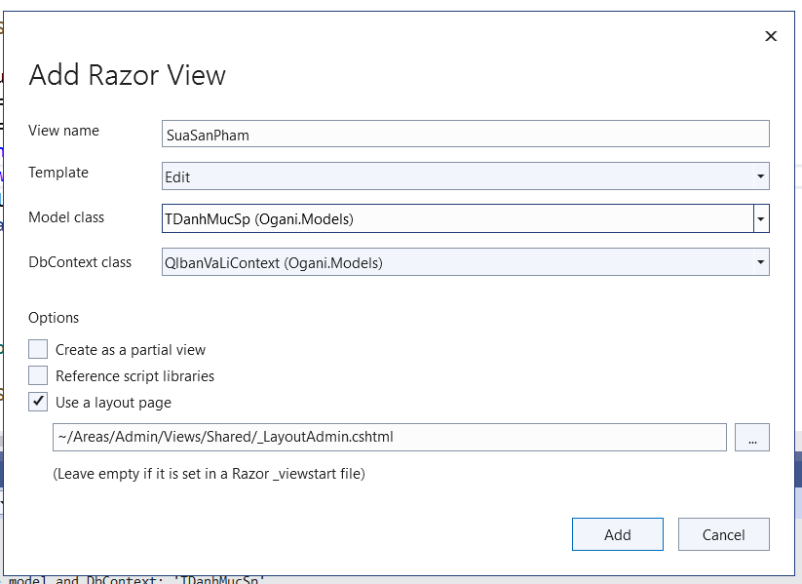

Them: @addTagHelper *, Microsoft.AspNetCore.Mvc.TagHelpers

Va method=”post”

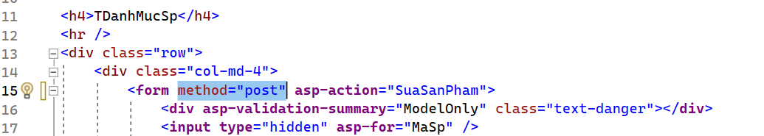

* Sua ben index

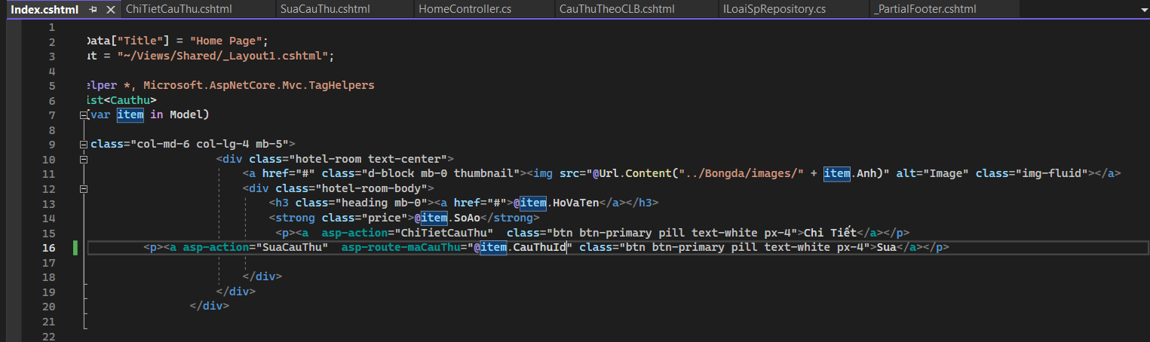

Sua edit -> Suasanpham

<**a** **asp-action**="SuaSanPham" **asp-route-masp**="@item.MaSp">Edit</**a**> |

